3.2 I can assess what permissions are needed for different users and content

Social media accounts and websites which host forums and different administrative rights often have restricts on how much each person can do with the content and the users who use the website.

For example on Meta’s Instagram and Facebook you can have brands post stuff on your social media account

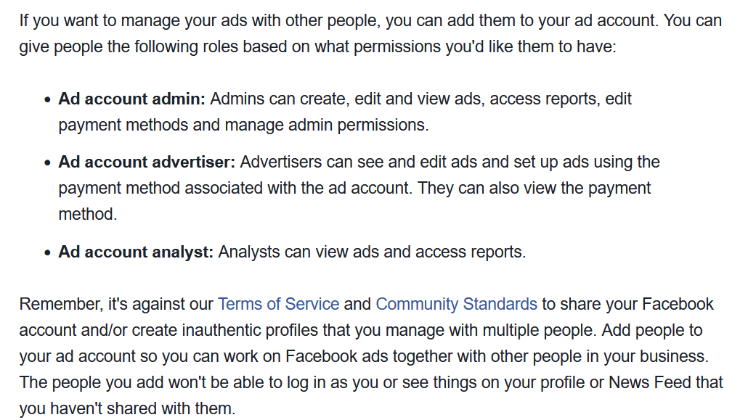[The above photo shows the types of roles that be shared across a social media account through Meta]

Wix is another example of a website where people can collaboratively share stuff and some users may only buy stuff through it and others may add or remove users.

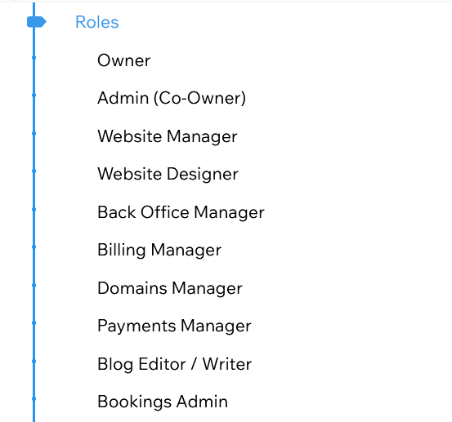

[The above photo shows a few roles that a Wix site can have]

<https://support.wix.com/en/article/roles-permissions-overview> < site takes you the full overview

Although sites can also be restricted to just a few permissions like creating an order and buying stuff.

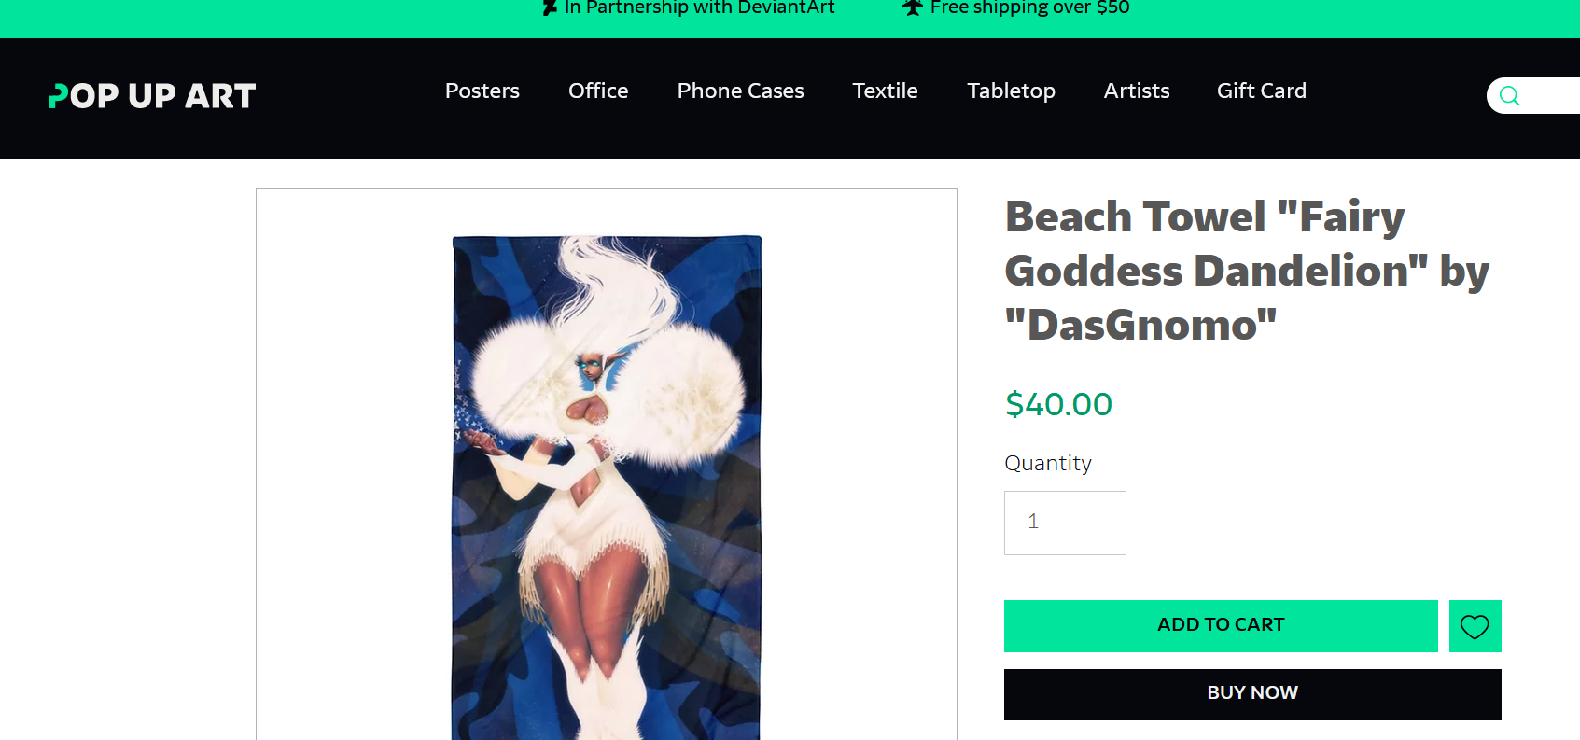

[The above photo shows a screenshot from a Sister-site of Deviantart, a site where people share and sell their creations such as paintings, 3D modelling or literature]